Flutes around the World

ACTIVITY SUMMARY
In this activity, students explore types of flutes from various regions of the world. Students will research one of the instruments using online sources and write a brief report or create a multimedia presentation to share with the class.

STUDENTS WILL BE ABLE TO
  - identify commonalities and differences in music instruments (the flute) from various cultures. (CA VAPA Music 3.0 Cultural Context)
  - gather information from sources to answer questions. (CA CCSS W 8)
  - describe objects with relevant detail. (CACCSS SL 4)

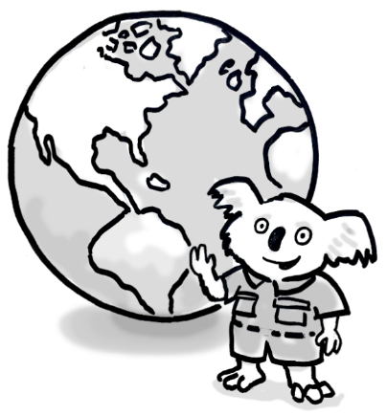
STEPS:
- Tell students: There are a vast number of different types of flutes that exist worldwide. The concert flute found in symphony orchestras is one example, but there are many other varieties of the flute, too. Flutes of different shapes and sizes are found in many cultures and play an important role in the musical traditions of regions around the globe!
Here are a few examples of different flutes and the region(s) where they are played:
American Indian Plains flute (North America)
Andean panpipe (South America)
Bansuri (India)
Dizi (China)
Fife (Europe)
Ney (Middle East)
Nose flute (Polynesia)
Ocarina (Central America and South America)
Palendag (Phillipines)
Penny whistle (Ireland)
Recorder (Europe)
Shakuhachi (Japan)
Washint flute (Ethiopia)
- Using an online search, have students choose a type of flute from the list and research the instrument. Students should describe the instrument, the sound the instrument makes, and the kind of music that is traditionally played on it.
Students should also locate photos and videos of the instrument.

Some sample questions for students to answer:
- What is the instrument’s shape and size? From what material(s) is it made?
- How is sound produced on the instrument? (For example, blowing across the top or through a hole on the side)
- Where did the instrument originate? Did it spread to other regions?
- What cultural traditions are associated with the instrument and its music?

- Students should compile their findings in a short report or multimedia presentation, using pictures of the instrument, an audio example of how the instrument sounds, and an online video clip showing the instrument being played.
- Have students volunteer to share their presentations with the class. (Students should forward the audio/video links to the teacher for review; the teacher can then share the audio/video with the class as part of each student’s presentation.)
- As a class, discuss how these instruments are similar and different.

